**CSIS 434 – Theory of Programming Languages, Spring 2019**

**Project 2: 50 Points**

**Due Date: Thursday, February 28th @ 11:59PM**

The classic board game of Clue is one in which players attempt to solve a crime of murder. Players ask clues in order to determine a murderer, a weapon, and a room. (Motive is left for interpretation later. :P). We will expand upon this basic idea.

1. 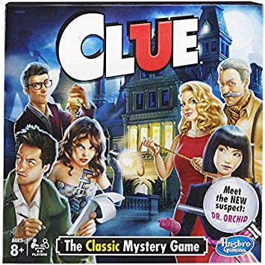Before the clue-gathering phase of the game begins, a moderator *secretly* enters suspect profiles and game data into the computer program. See the screen capture below to see what kinds of data the program will collect.
2. The computer program will randomly select one suspect who will be considered the ***murderer***. That murderer’s profile will be compatible with the characteristics for a suspect entered in Step 1.
3. The program will create a *rules file* which lists characteristics of a number of suspect. For details, see the *rules* *file*generated from the suspect and game data entered in step 1 above. The *rules file* will then be inserted (most likely copypasted) into the rules panel of the online Prolog site for the game play.
4. At this point the game can commence. Players attempt to determine the details of the crime but are only privy to small clues. Players will not know the suspects profiles, number of suspects, and number of weapons, age range or game data (e.g. places or times of day). Players *will* know that each suspect has a name, gender, age, and favorite weapon. A computer will deliver a query for each player to use. The computer-generated query will be copypasted into the query section of the online Prolog site. Below is an example of a computer-generated query:

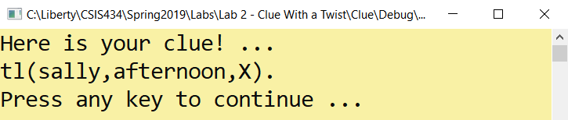

The snapshot below shows what happens when the player copypastes the computer-generated clue into the online Prolog site:

|  |  |
| --- | --- |
| General: | Where was *randomsuspect*  in *randomtimeofday*  ? |
| Specific: | **tl(sally,afternoon,X).** |
| Computer-Generated Query |  |

**Note: The computer program will need to generate additional rules, some with predicates, to implement some of the clues in the** **Clues Table** **below. The computer program will randomly select a clue number, examine its template, and then fill in with profile/game date provided by the moderator in order to create a usable query.**

The winning player will be able to replace the computer-generated clue with an accusation of his/her own:

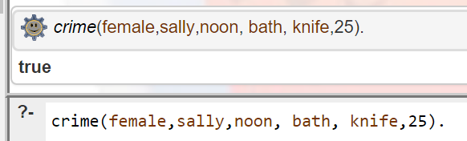

A player can only make one accusation like this. If the accusation is correct, he/she wins. If not he/she is not permitted to continue playing and the other players continue.

By the due date:

1. Upload the .cpp and .exe files for the Rules Generator program to Bb.
2. Upload the .cpp and .exe files for the Clues Generator program to Bb.

**Screen Capture for Creating the Rules File:**

Computer-Generated Text

User-Typed Text – all lowercase!

---------- Clue Game Generator ----------

How many weapons (Max 8)

5

Weapon 1:

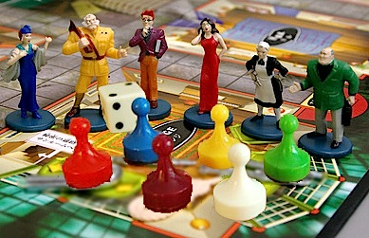rope

Weapon 2:

cat5

Weapon 3:

knife

Weapon 4:

candlestick

Weapon 5:

tickle

How many players (Max 10)

5

Name1:

mark

Gender1:

m

Age1:

57

Name2:

sally

Gender2:

f

Age2:

25

Name3:

billybob

Gender3:

m

Age3:

27

Name4:

falisha

Gender4:

f

Age4:

22

Name5:

jeremiah

Gender5:

m

Age5:

33

How many locations (Max 6)

4

Location 1:

kitchen

Location 2:

bath

Location 3:

study

Location 4:

deck

How many times (Max 6)

5

Time 1:

morning

Time 2:

afternoon

Time 3:

noon

Time 4:

night

Time 5:

Afterdinner

User data collected … now play the game!

**Rules File**

Note.

1. The rules must be sorted
2. For each suspect the moderator enter the age and gender – the weapon is assigned by the program.
3. The tl (timelocation) rules are generated by the program.
4. The crime rule is generated by the program.

age(billybob,27).

age(falisha,22).

age(jeremiah,33).

age(mark,57).

age(sally,25).

crime(female,sally,noon, bath, knife,25).

female(falisha).

female(sally).

male(billybob).

male(jeremiah).

male(mark).

tl(billybob,afterdinner, kitchen).

tl(billybob,afternoon, deck).

tl(billybob,morning, deck).

tl(billybob,night, deck).

tl(billybob,noon, study).

tl(falisha,afterdinner, kitchen).

tl(falisha,afternoon, kitchen).

tl(falisha,morning, deck).

tl(falisha,night, bath).

tl(falisha,noon, study).

tl(jeremiah,afterdinner, deck).

tl(jeremiah,afternoon, bath).

tl(jeremiah,morning, study).

tl(jeremiah,night, study).

tl(jeremiah,noon, kitchen).

tl(mark,afterdinner, kitchen).

tl(mark,afternoon, study).

tl(mark,morning, kitchen).

tl(mark,night, study).

tl(mark,noon, study).

tl(sally,afterdinner, bath).

tl(sally,afternoon, bath).

tl(sally,morning, bath).

tl(sally,night, deck).

tl(sally,noon, bath).

weapon(billybob,tickle).

weapon(falisha,rope).

weapon(jeremiah,tickle).

weapon(mark,cat5).

weapon(sally,knife).

**Clues Table**

|  |  |  |  |  |  |
| --- | --- | --- | --- | --- | --- |
| # | Clue % | Generic Template | Example with Sample Data | Output Message | Query |
| 1 | .06  05 | Where was *random suspect*  in *random timeofday*  ? | Where was sally in the afternoon? | sally was in the bathroom in the afternoon | tl(sally,afternoon,X). |
| 2 | .04  09 | Was *random suspect* ever in *location?* | Was mark ever in the kitchen? | mark was in the kitchen on the day of the murder | tl(mark,_,kitchen) |
| 3 | .05  14 | What is *random suspect’s* weapon? | What is falisha’s weapon? | falisha likes to use a rope |  |
| 4 | .05  19 | List a *gender* suspect. | List a male suspect. | billybob is a male |  |
| 5 | .05  24 | How old is *random suspect?* | How old is falisha? | falisha is 22 years old |  |
| 6 | .03  27 | Who are all the *gender?* | Who are all the males? | Male suspects: mark billybob jeremiah |  |
| 7 | .04  31 | Are any suspects over *integer*  *years* old? | Who are over 30 years old? | These suspects are over 30: jeremiah mark |  |
| 8 | .04  35 | Are any suspects *integer age*  years old? | Is anyone 22 years old? | At least one suspect is over 22 years old. |  |
| 9 | .05  40 | How many suspects use this *weapon*? | How many suspects use rope? | One suspect uses the knife weapon. |  |
| 10 | .04  44 | What suspects use this weapon? | What suspects use tickle weapon? | billybob jeremiah use the tickle weapon |  |
| 11 | .03  47 | Where was *random suspect* all day? | Where was billybob all day? | billybob was here during the day:  morning kitchen etc. |  |
| 12 | .04  51 | Where *random suspect1* and *random suspect2* ever at the same place at the same time? | Where *falisha* and *billybob* ever at the same place at the same time? | falisha and billybob were at the kitchen afterdinner. |  |
| 13 | .03  54 | What is the gender of the murdered? |  | The murderer is female. |  |
| 14 | .02  56 | What is the name of the murderer? |  | The murderer is sally. |  |
| 15 | .03  59 | When was the murder committed? |  | The murder occurred at noon |  |
| 16 | .03  62 | Where was the murder committed? |  | The murder occurred in the bathroom |  |
| 17 | .03  65 | What weapon was used for the murder? |  | The murderer used a knife. |  |
| 18 | .03  68 | How old is the murderer? |  | The murderer is 25. |  |
| 19 | .03  71 | *Random suspect* was not the murderer | Mark was not the murderer. | Mark was not the murderer |  |
| 20 | .03  74 | *Random weapon* was not used in the murderer | A rope was not used in the murder. | A rope was not used in the murder |  |
| 21 | .03  77 | The murder did not occur at *Random time* | The murder did not occur in the morning. | The murder did not occur in the morning. |  |
| 22 | .03  80 | The murder did not occur at *Random location?* | The murder did not occur in the kitchen. | The murder did not occur in the kitchen |  |
| 23 | .05  85 | When was *random person1*  at *random location?* | When was sally on the deck?  Or  When was sally at the kitchen? | sally was on the deck at night  or  sally was never in the kitchen |  |
| 24 | .03  88 | *Random person* was never in the *location* | sally was never in the kitchen. | sally was never in the kitchen |  |
| 25 | .03  91 | What are the possible scenes of the murder? |  | Suspects were seen in the kitchen bath deck study |  |
| 26 | .03  94 | When were the suspects seen? |  | Suspects were seen  afterdinner afternoon  morning night noon |  |
| 27 | .02  96 | Is the murderer *random suspect1* **or** *random suspect2*? | Is the murderer falisha or mark?  Or  Is the murderer sally or mark? | The murderer was not falisha or mark.  Or  The murderer was either sally or mark. |  |
| 28 | .02  98 | Was the murder weapon *random weapon1* or *random weapon2* ? | Was the weapon used *cat5* or *tickle?*  Or  Was the weapon used *cat5* or *knife?* | The murder weapon was not cat5 or tickle.  Or  The murder weapon was either cat5 or knife. |  |